HỘI ĐỒNG THI TUYỂN CẤP TỈNH
***
HƯỚNG DẪN ÔN THI
MÔN TIẾNG ANH
Trình độ tương đương bậc 2 khung năng lực ngoại ngữ Việt Nam theo quy định tại Thông tư số 01/2014/TT-BGDĐT, ngày 24/01/2014 của Bộ Giáo dục và Đào tạo
(Ban hành kèm theo văn bản số 01-CV/HĐTT ngày 28 /4/2017 của Chủ tịch Hội đồng thi tuyển cấp tỉnh)
- ĐỊNH DẠNG CÁC PHẦN THI
Phần thi | Yêu cầu về kiến thức | Số câu hỏi | Phân bố điểm
Nghe | - Có thể hiểu những cụm từ và cách diễn đạt liên quan tới nhu cầu thiết yếu hằng ngày (về gia đình, bản thân, mua sắm, nơi ở, học tập và làm việc…) khi được diễn đạt chậm và rõ ràng.  - Có thể hiểu được ý chính trong các giao dịch quen thuộc hằng ngày khi được diễn đạt chậm và rõ ràng. | 20 | 25 %
Đọc hiểu | - Có thể hiểu và tìm được các thông tin cụ thể trong các đoạn đọc đơn giản thường gặp hằng ngày như quảng cáo, thực đơn, danh mục tham khảo và thời gian biểu.  - Có thể hiểu được đoạn văn bản ngắn với các chủ đề quen thuộc trong đời sống hàng ngày, các biển báo, thông báo trong các tình huống hằng ngày ở nơi công cộng (trên đường phố, trong nhà hàng, ga tàu hỏa…) hay ở nơi làm việc, ví dụ biển chỉ đường, biển hướng dẫn, biển cảnh báo nguy hiểm. | 20 | 25 %
Ngữ pháp-Từ vựng | - Có đủ vốn từ để thực hiện các giao dịch thường nhật liên quan đến các tình huống và chủ đề quen thuộc.  - Biết sử dụng một số quy luật ngữ pháp như: Thì hiện tại/quá khứ đơn giản, hiện tại/quá khứ tiếp diễn, hiện tại hoàn thành, tương lai đơn; Đại từ quan hệ; Cấu trúc so sánh; Động từ kết hợp với động từ dạng danh động từ và động từ nguyên thể; Câu điều kiện loại 1 và 2, Mạo từ, Giới từ và cụm giới từ đơn giản. | 20 | 25 %
Viết | - Có thể viết các mệnh đề, câu đơn giản và nối với nhau bằng các liên từ như: và, nhưng, vì….  - Có thể viết những cụm từ hay những câu đơn giản về gia đình, điều kiện sống, quá trình học tập và công việc hiện tại.  - Có thể viết những thư cá nhân đơn giản để cảm ơn hoặc xin lỗi.  - Có thể lựa chọn và tái tạo những từ, cụm từ quan trọng, hay những câu ngắn từ một đoạn văn ngắn trong khả năng và kinh nghiệm giới hạn của bản thân. | 2 phần | 25 %

II. CÁC DẠNG BÀI TẬP MINH HỌA

1. LISTENING (NGHE)

Exercise 1. You will hear five short conversations. There is one question for each conversation. For question 1-5, listen and put a tick (√) under the right answer. You will each conversation twice.

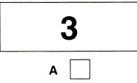 | 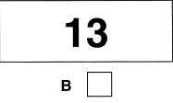 | 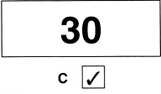

1. What was the weather like when the holiday began?
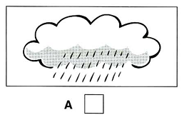 | 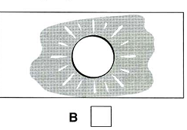 | 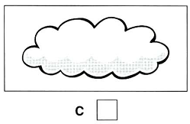
2. What did Peter buy?
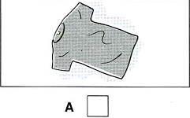 | 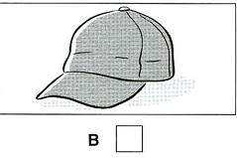 | 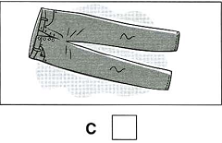
3. How far is it to the beach?
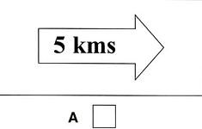 | 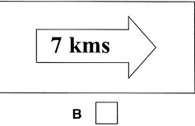 | 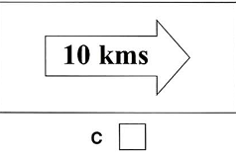

4. What will Tim and his dad play today?
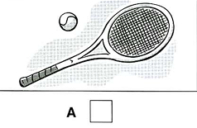 | 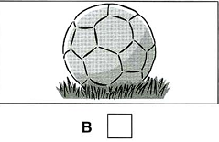 | 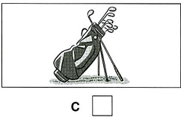
5. What does the woman want?
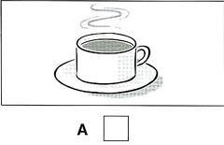 | 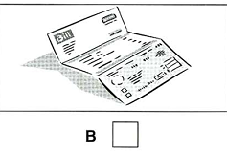 | 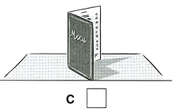

Exercise 2. Listen to a woman talking to her son, Chris, about the things he has to do What will he do at each time? For questions 6-10, write a letter A-H next to each time. You will the conversation twice.

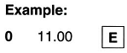

Times | Things to do
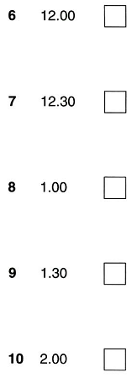 | 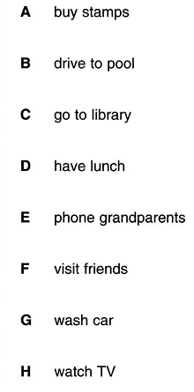

Exercise 3. Listen to Amanda talking to a friend about birthday party. For questions 11-15, listen and tick (√) the best answer (A, B or C). You will the conversation twice.

0. How many people can come to the party?
A. 8 | B. 11 √ | C. 18

11. What ice cream will they have at the party
A. Coffee | B. Lemon | C. Apple
12. What is broken?
A. the CD player | B. the cassette recorder | C. the guitar
13. Whose birthday is it?
A. Emma’s | B. Joan’s | C. Amanda’s sister’s
14. What present has Amanda bought?
A. a camera | B. a video | C. a football
15. What time should people arrive at the party?
A. 8 p.m. | B. 8.30 p.m. | C. 9.30 p.m.

Exercise 4: You will hear a woman asking for some information about a job. Listen and complete questions 16-20. You will the conversation twice.

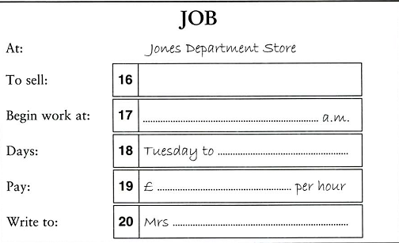

2. READING (ĐỌC)
Exercise 1. Which notice (A-H) says this (1-5)? Read the questions (1-5) and mark the correct letter A-H.

Example:
0. You do not have to pay here. → E
1. If you need a job, try telephoning this number.  2. You should pay with cash here.  3. Sometimes you don’t have to book here.  4. If you find what this person is looking for, you will get some money.  5. This shop has lower prices than the other shops near to it. | A | 
 | B | We do not take traveller’s cheques or credit cards.
 | C | 
 | D | 
 | E | 
 | F | 
 | G | 
 | H | 

Exercise 2. Read the email and choose the best answer A, B or C to the questions.

To: Ellie Crest
Subject: Surfing Holiday

Hi Ellite
I’m so pleased you can come surfing in August! Paul, Rose and Kevin are coming too, so there will be five of us. We’ve decided to return to New Sands, because the surf board hire is so cheap there.
I’m starting to think about accommodation. We won’t camp again after last year! I hated staying in a tent in all that rain!
Kevin wants to hire a caravan. There are some nice ones with 3 bedrooms, showers and cooking facilities. The problem is, none of the caravan parks take short bookings in the summer. The minimum stay is a week. It’s a shame because there are several nice parks near the beach.
There’s a youth hostel in New Sands. It’s the cheapest option after camping, and there’s a big kitchen and dining room where we can cook. The problem is, accommodation is in dormitories and I don’t really want to sleep with strangers.
There are a few guest houses in New Sands. Some have triple rooms, so we’d only need to book two rooms. They’re not expensive, but we wouldn’t be able to cook there. We’d have to eat out at restaurants, or eat sandwiches for every meal! We’ll have to book soon if we choose that option, because many guest houses are already full. The hotels in New Sands are far too expensive, even though I’d love to stay at the Sunrise Pavilion with its rooftop pool!
The final option is to rent a cottage. Few cottages offer mid-week breaks in summer, but I found one. It has three bedrooms - a double, a single and a twin, so two of us would have to share a bed! There’s a big kitchen diner with a microwave, washing machine and dishwasher. The living room has a TV and DVD player. There’s just one bathroom, but there’s a separate WC. There’s a nice garden too. The problem is, it’s 5 miles from the beach, so we’d have to hire a car, because there aren’t any buses.
Let me know which option you prefer.
Cheers
Natalie
1 Last year the friends stayed in a…………………
A. caravan | B. tent | C. youth hostel
2 Last year the friends had problems with…………...…
A. the weather | B. the transport. | C. their surf boards

3 The friends want to stay in New Sands for…………….
A. a week | B. a week and a half | C. less than one week
4 The problem with the caravan park is that……………
A. caravans are only available for full weeks
B. there are not have enough beds for everyone
C. all the caravans are fully booked
5 Natalie doesn’t want to stay in the youth hostel because………….
A. it is too expensive
B. she doesn’t want to share with people she doesn’t know
C. it does not have any self-catering facilities
6 The guest house ………….
A. is too expensive | B. does not have self-catering facilities | C. does not have a restaurant.
7 The Sunrise Pavilion……………
A. is too expensive | B. does not have a swimming pool | C. is fully booked
8 Natalie chose this cottage because…………
A. it is cheaper than the other cottages
B. everyone can sleep in a different room
C. it allows people to stay for less than a week
9 In the cottage,………………
A. the dining area and living area are in the same room.
B. the shower and toilet are in the same room
C. the cooking area and dining area are in the same room
10 The problem with the cottage is…………..
A. its size | B. its location | C. its price

Exercise 3. Read the article about two sisters. Are the sentences ‘Right’ or ‘Wrong’? If there is not enough information to answer ‘Right’ or ‘Wrong’, choose ‘Doesn’t say’.

Something very strange happened to Tamara. She never knew she had a twin sister until she started university!
Tamara was born in Mexico. Her parents could not look after her so she went to live with a family in Manhattan, USA.
When Tamara was twenty years old, she started university in Long Island. She enjoyed her university life. But one day she was walking home from class, and a student smiled at her. “Hello Adriana!” said the student. “I’m not Adriana,” said Tamara.
This happened to Tamara again and again. People Tamara didn’t know kept calling her Adriana. It was very strange. One day, when a woman called her Adriana, Tamara asked “Why do you keep calling me Adriana?”
The woman replied, “You look like my friend Adriana. You have the same face and the same hair. Is Adriana your sister?” Tamara said that she did not have a sister called Adriana. But she was interested in this girl Adriana. Finally she asked someone for Adriana’s email address.
When Tamara wrote to Adriana, she found out that they both had the same birthday, they looked the same and both of them were from Mexico. When Tamara went to live with the family in Manhattan, Adriana moved to Long Island to live with a family there. It had to be true! Adriana and Tamara were twin sisters!

1. Tamara and her sister were both born in Mexico.
A. Right | B. Wrong | C. Doesn’t say
2. Tamara’s parents moved from Mexico to Manhattan.
A. Right | B. Wrong | C. Doesn’t say
3. People called Tamara “Adriana” many times.
A. Right | B. Wrong | C. Doesn’t say
4. Adriana wrote to Tamara first.
A. Right | B. Wrong | C. Doesn’t say
5. Adriana always knew she had a twin sister.
A. Right | B. Wrong | C. Doesn’t say
6. Adriana is Tamara’s only sister.
A. Right | B. Wrong | C. Doesn’t say
7. Adriana was a student at Long Island University.
A. Right | B. Wrong | C. Doesn’t say
8. Adriana had only recently arrived in Long Island.
A. Right | B. Wrong | C. Doesn’t say

Exercise 4. Read the information about Schnauzer dogs. Choose the best word A, B or C for each space.

Schnauzer Dogs
There are three sizes .....0.... Schnauzer dog.

The two smaller sizes first ... 1... to England over 50 years ago, but the Giant Schnauzer has not ...2... here very long. The name Giant is a good one because the dogs are 65 to 67 cm high.
All the dogs ...3... long hair, which should be cut quite often. Most smaller Schnauzers ...4... grey in colour, ...5... the Giant Schnauzer is usually black.
Schnauzers come from Germany, where farmers use the dogs to help ...6... with their sheep, and they are also used ...7... the police, because Schnauzer dogs are very intelligent.
A Schnauzer makes ...8... nice family dog. It is friendly and very good with young children.

EXAMPLE:
0. A. with B. of C. in

1 | A came | B come | C. comes
2 | A. being | B be | C been
3 | A has | B have | C had
4 | A were | B is | C are
5 | A or | B if | C but
6 | A them | B him | C us
7 | A from | B by | C to
8 | A the | B a | C any

Exercise 5. Complete this letter. Write ONE word for each space.
28 Long Road
Brighton
Dear Pat,
I arrived (Example: here) three weeks ago. I'm studying at a language school ...1... Brighton. The students come ...2... many different countries and I ...3... made a lot of new friends.
There ...4... classes for five hours every day. I like ...5... teacher very much. ...6... name is John and he helps me ...7... I make a mistake.
I want ...8... visit London next weekend because I ..9... going back to my country on Monday. Can I see you there? Please write to ...10... soon.
With best wishes from
Maria

3. GRAMMAR-VOCABULARY (NGỮ PHÁP - TỪ VỰNG)
Exercise 1. Choose the best answer A, B, C or D to complete the sentences:
1. Eli likes to play .................. volleyball.
A. a | B. an | C. the | D. no article
2. I’ll be at home .................. Saturday morning. You can phone me then.
A. at | B. on | C. in | D. by
3. “What’s wrong with Henry ? ” – “ He needs ..................”
A. work harder | B. to work harder | C. working harder | D. works harder
4. I still can’t believe it ! My bicycle .................. last night.
A. was stolen | B. was stealing | C. stolen | D. stole
5. Mr.Wilson is .................. as Willie to his friend.
A. knew | B. know | C. known | D. knowing
6. We’ll get wet if we …………. out.
A. go | B. goes | C. went | D. had gone
7. The children .................. are playing in the yard are Mr. Brown’s nephews.
A. whom | B. that | C. which | D. where
8. They had camped once before, .................. they knew what to take.
A. because | B. now | C. so | D. since
9. Although, it's raining, .................. are still working in the fields.
A. they | B. but they | C. and they | D. so they
10. Tomorrow ....................... Sunday. What will you do?
A. is | B. will be | C. are | D. was

Exercise 2. What is the word for each of the following descriptions.

EXAMPLE:

0. If you go on a camping, you may sleep in this. T ─ ─ ─
→ answer: TENT
1. This is where you lie in the sun and go swimming. B ─ ─ ─ ─
2. You can pack all your holiday clothes in this. S ─ ─ ─ ─ ─ ─ ─
3. Without this you can not go to some countries. P ─ ─ ─ ─ ─ ─ ─
4. This is what you dry yourself after you go swimming. T─ ─ ─ ─
5. You need to put a stamp on this to send it to a friend. P─ ─ ─ ─ ─ ─ ─

6. You can buy all your vegetables here. M─ ─ ─ ─ ─
7. Some boys and girls have to wear this at school. U─ ─ ─ ─ ─ ─
8. If you don’t want to eat at home, you can buy a meal here. R─ ─ ─ ─ ─ ─ ─ ─ ─
9. People wear this in the winter when they go outside. C─ ─ ─
10. You buy a ticket to watch a play here. T─ ─ ─ ─ ─ ─

Exercise 3. Read the sentences and choose the best word A, B, C or D for each space
1. Sarah is doing a four-year ......................... in Business Studies.
A. class | B. lesson | C. course | D. point
2. The university secretary was there to ..................... all the new students.
A. invite | B. speak | C. welcome | D. talk
3. On the first day, Sarah ....................... some of her new teachers.
A. met | B. knew | C. remembered | D. said
4. Today, Sarah is .................... reading her business books.
A. correct | B. useful | C. busy | D. smart
5. Next month, She is hoping to .....................the university swimming club.
A. play | B. join | C. become | D. learn
6. Indira has to ...................... the customers and take them to a table.
A. welcome | B. arrive | C. invite | D. say
7. The customers ................... what they want to eat and she writes it down in a notebook.
A. speak | B. ask | C. choose | D. focus
8. Indira can ................. any extra money which customers leave for her on the table.
A. change | B. keep | C. check | D. pay
9. If Indira has lunch at the restaurant, she doesn’t have to ...................... for her food.
A. buy | B. spend | C. pay | D. rent
10. In a few years, Indira ......................... to study Food Science at university.
A. hopes | B. changes | C. admits | D. warns

4. WRITING (VIẾT)
Exercise 1. Read the information about a school theatre trip and Complete Emma’s notes.

Join us in a school trip to  Stratford-on-Avon  on Saturday 5th June  You can spend the morning shopping. For lunch we will have a picnic near the river. In the afternoon we will see William Shakespeare’s play ‘Macbeth’.  Price: £15  Meet at River Road car park: 8.30 a.m.  Return: 6.30 p.m. | Dear Students,  Our Stratford-on-Avon trip is very popular. Unfortunately we cannot get enough tickets to see ‘Macbeth’. So we have tickets for ‘As you like it’ instead. The tickets are a little more expensive so the trip will now cost £18 per person.  Arrival and departure times are the same.  Mrs. Wentworth  English Teacher
Emma’s notes:
School Trip
1. Name of Town: ………………………………..
2. Name of the Play: …………………………….
3. Cost: ………………………………………. …
4. Meeting place: ………………………………..
5. Return time: ……………………………..….. .

Exercise 2. Read the note from your friend Richard and write a postcard to tell him what he wants to know. Write 25-35 words.
It's great that you're coming to see me in England. Tell me when you are coming, how long you want to stay and what you want to do.
Write soon!
Richard

Exercise 3. Write a paragraph (70-80 words) about your favorite hobby.

III. GIỚI THIỆU TÀI LIỆU THAM KHẢO
1. Tài liệu giấy: gồm các giáo trình sau:
- New English File -Pre-intermediate, Student’s Book & Workbook. NXB: Oxford.
- English Pronunciation in Use. Elementary. NXB: Cambridge.
- Grammar Spectrum 1. NXB: Oxford.
- Cambridge Objective Ket. NXB Cambridge.
- Cambridge Key English Test 1, 2, 3, 4, 5. NXB: Cambridge.
2. Tài liệu qua mạng: gồm các liên kết sau:
- http://www.englishbanana.com/free-resources.html.
- https://www.vocabulary.com/.
- http://www.englisch-hilfen.de/en/.
- http://gamestolearnenglish.com/.
- http://english07.com/grammar/grammar_practice_for_preintermediate_students.php.
- http://www.5minuteenglish.com/grammar.htm.
- http://www.esolcourses.com/content/topicsmenu/preintermediate.html.
- http://web2.uvcs.uvic.ca/elc/studyzone/330/reading/.

HỘI ĐỒNG THI TUYỂN

